CS309 DBMS LAB

ASSIGNMENT # 3

B.Catherine Joyce Date: 2/10/21

CS19B1015

Done using MySQL 8.0 Line Client

Database name - library_schema

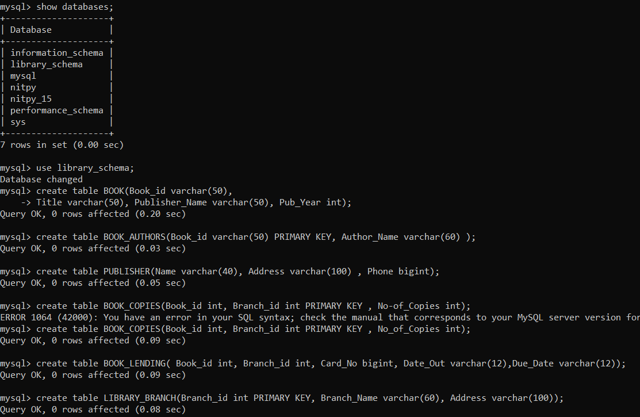

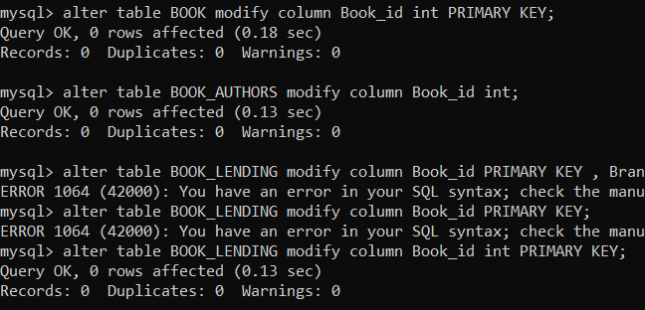

Inserting Values-

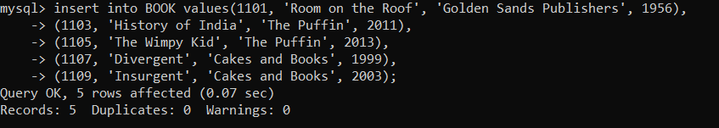

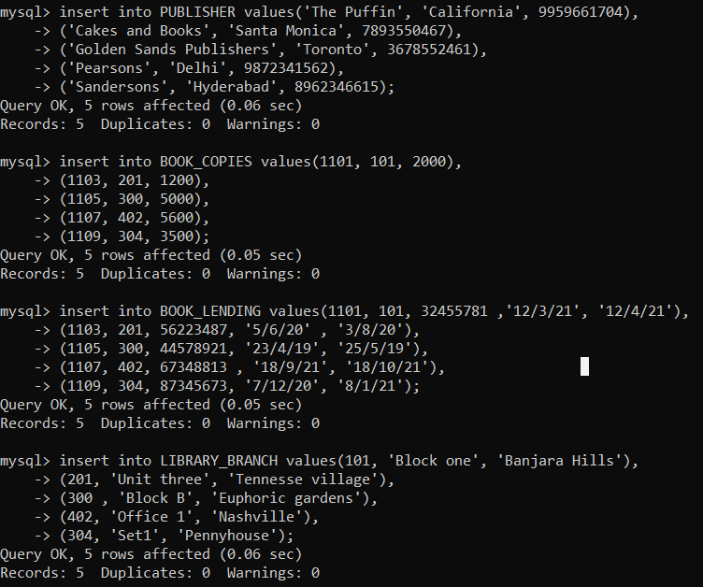

Showing tables-

1. BOOK

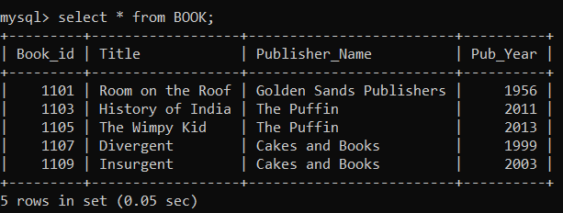

2.BOOK_AUTHORS

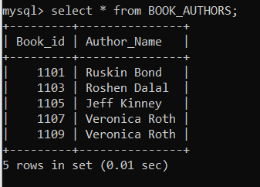

3.PUBLISHER

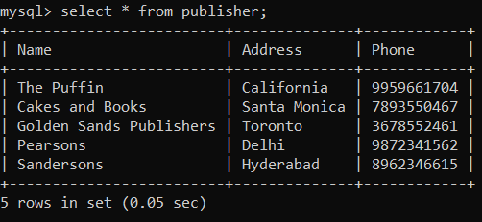

4.BOOK_COPIES

5.BOOK_LENDING

6. LIBRARY_BRANCH

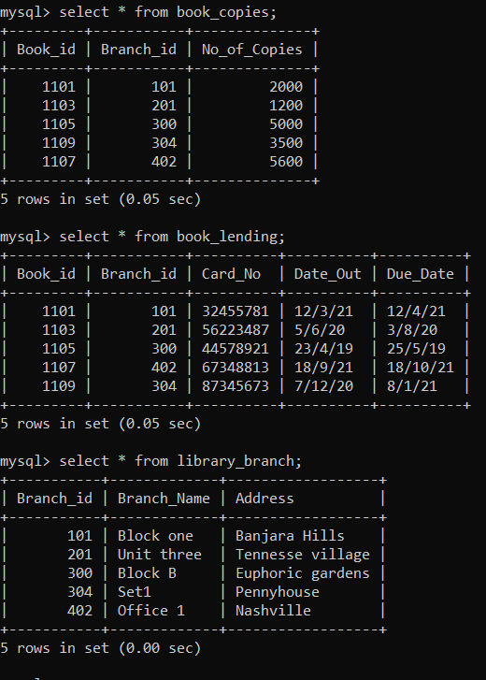

Updated Card_No in BOOK_LENDING table

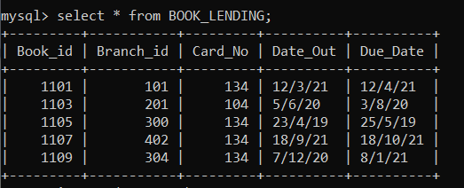

SQL QUERIES-

1. SELECT b.Book_id, b.Title, b.Pulisher_Name, a.Author_Name, c.No_of_Copies, l.Branch_id

FROM BOOK b, BOOK_AUTHORS a, BOOK_COPIES c, LIBRARY_BRANCH l

WHERE b.Book_id = a.Book_id AND b.Book_id = c.Book_id AND l.Branch_id = c.Branch_id;

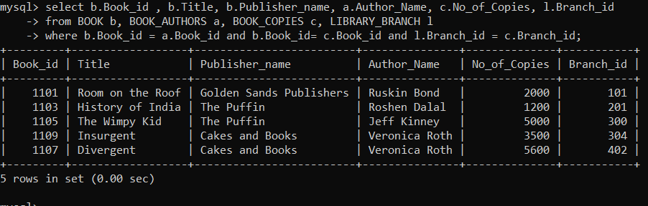

1. SELECT Card_No FROM BOOK_LENDING

WHERE Date_Out between ‘1/1/21’ AND ‘1/6/21’

GROUP BY Card_No HAVING count(*)>3;

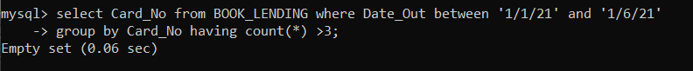

The query results in an empty table, as there were no borrowers who borrowed more than 3 books from jan 2021 to june 2021.

1. DELETE FROM BOOK WHERE Book_id = 1103;

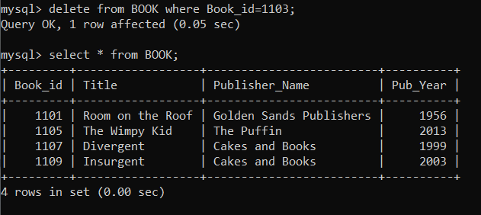

Deleting tuple with Book_id 1103 from all tables

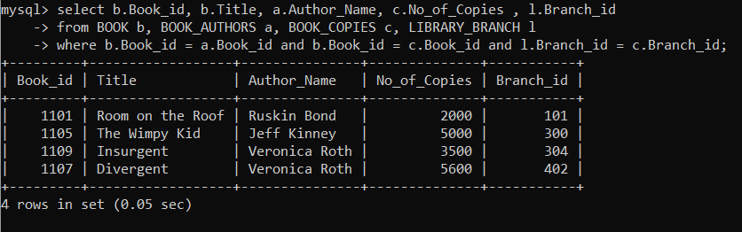

1. CREATE VIEW v_pub AS SELECT Pub_Year FROM BOOK;

To display view - SELECT * FROM v_pub;

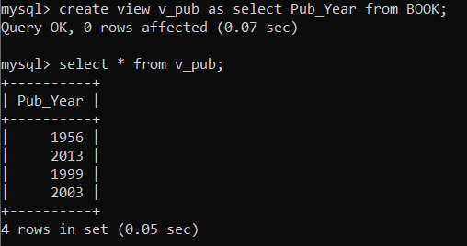

1. CREATE VIEW v_details AS SELECT b.Book_id, b.Title, c.No_of_copies

FROM BOOK b, BOOK_COPIES c

WHERE b.Book_id = c.Book_id;

To display the view - SELECT * FROM v_details;

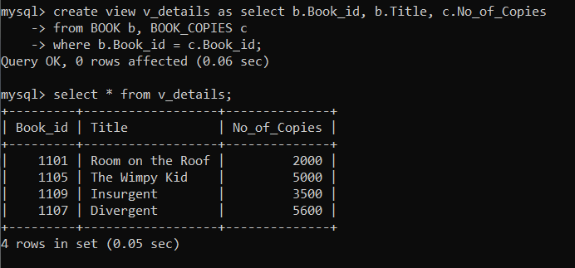

Result - The queries were performed and outputs were shown successfully